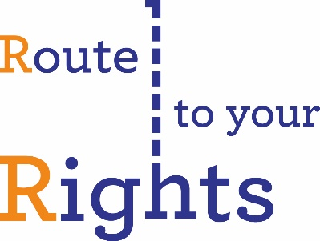

Are you a migrant to the UK? Have you been here at least 3 years? We want to hear from you!
Route To Your Rights is a new MRN project exploring what exposes
migrants to problems like homelessness and exploitation at work, and what measures people take to overcome them.
We are hoping to interview migrant workers of any nationality and immigration status about experiences of work, housing, and access to legal advice in the UK. The interview shouldn’t take more than 1 hour. You will be given a £10 voucher for your time.
To take part you will need to:
- Live in London
- Be over 18
- Have migrated to the UK in 2014 or earlier
- Have arrived in the UK by any route but the Tier 1 Visa
- Be willing to discuss your early experiences in the UK anonymously.
We can provide an interpreter if necessary. We won’t share your name or personal details with any other organisations.

If you have questions or would like to take part, contact Gracie Bradley, Project Manager, at vme@migrantsrights.org.uk / 020 7336 9415.

